Mobile App Wireframing
Design a simple low-fidelity wireframe for a mobile application that focuses on structure, layout, and user flow rather than visual design.
Objectives
- Identify user requirements through basic research.
1. User Research
Problem Statement
Many students experience stress, anxiety, academic pressure, and emotional challenges during their higher education journey. Due to stigma and limited access to support, they often struggle to seek professional help when needed.
Target Users
- College and university students (18–25 years)
- Students facing academic stress and emotional challenges
- Students seeking accessible mental health support
User Needs
- Monitor daily mood and emotional well-being
- Access professional counseling services
- Receive immediate emergency support
- Track mental wellness progress
- Access mental health resources in one place
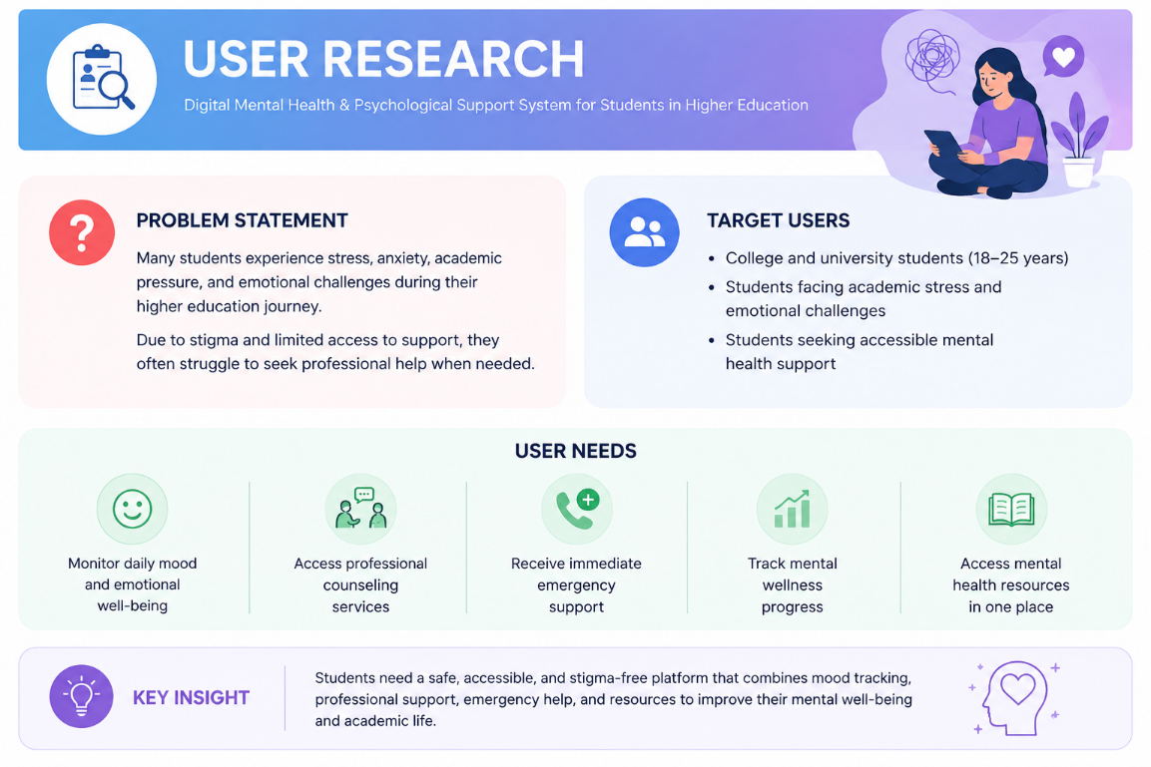
- Develop a user persona representing the target audience.
2. User Persona
Name: Aarav Sharma
Age: 21 Years
Occupation: BCA Student
Goals
- Manage academic and personal stress
- Improve mental well-being
- Access counseling support conveniently
- Track emotional health regularly
Pain Points
- Hesitates to discuss mental health concerns
- Difficulty balancing studies and personal life
- Limited awareness of available support services
- Needs quick access to emergency assistance during stressful situations
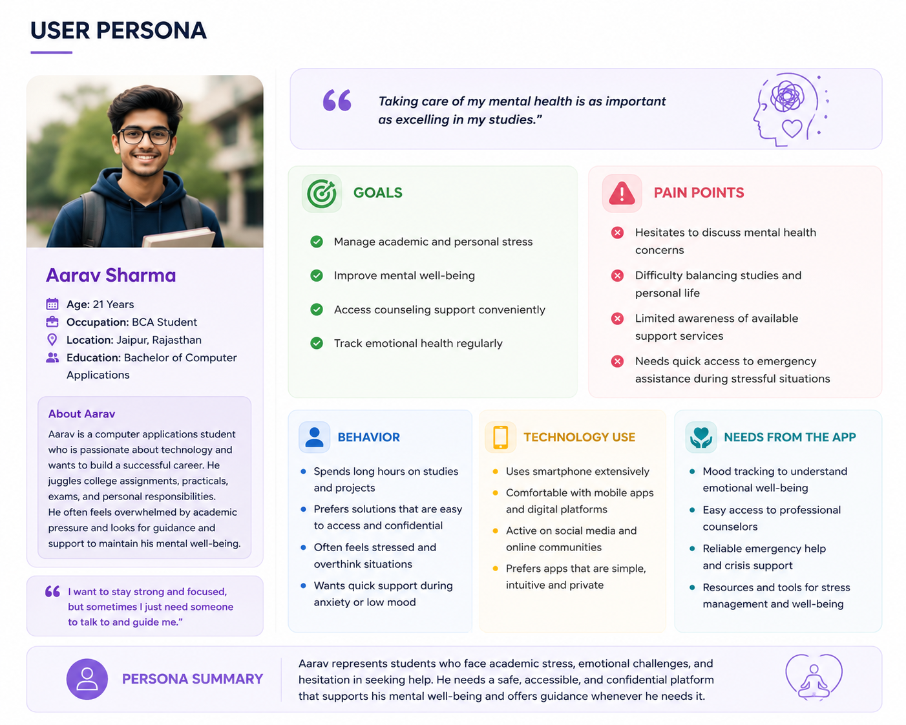
- Create a clear user flow to map the user journey.
3. User Flow Chart
Based on my given wireframe screens (Home → Mood Activity → Counselor → Emergency → Profile), here's a clear User Flow Chart for MINDCARE App project:
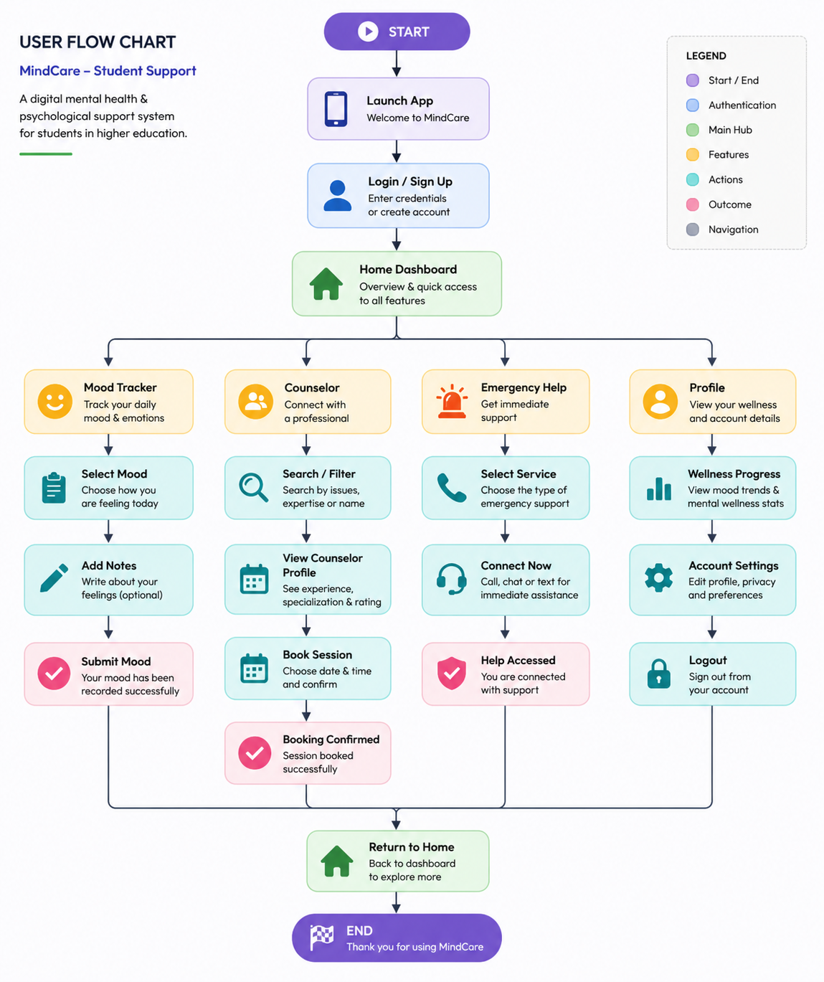

- Design low-fidelity wireframes using Figma or Adobe XD.
4. Wireframe Features Overview
1. Home Screen
Provides quick access to Mood Tracker, Resources, Counselor Booking, and Emergency Help while displaying wellness activity.
2. Mood Activity Screen
Allows students to record their daily mood and add notes about their feelings.
Counselor Screen
Enables students to browse available counselors and book counseling sessions.
3. Emergency Screen
Provides instant access to emergency services, campus counselors, crisis helplines, and text support.
4. Profile Screen
Displays user information, mental wellness progress, and account settings.
5. Expected Outcome
The application aims to provide a safe, accessible, and user-friendly platform that supports students' mental health through mood tracking, professional counseling, emergency assistance, and wellness monitoring.
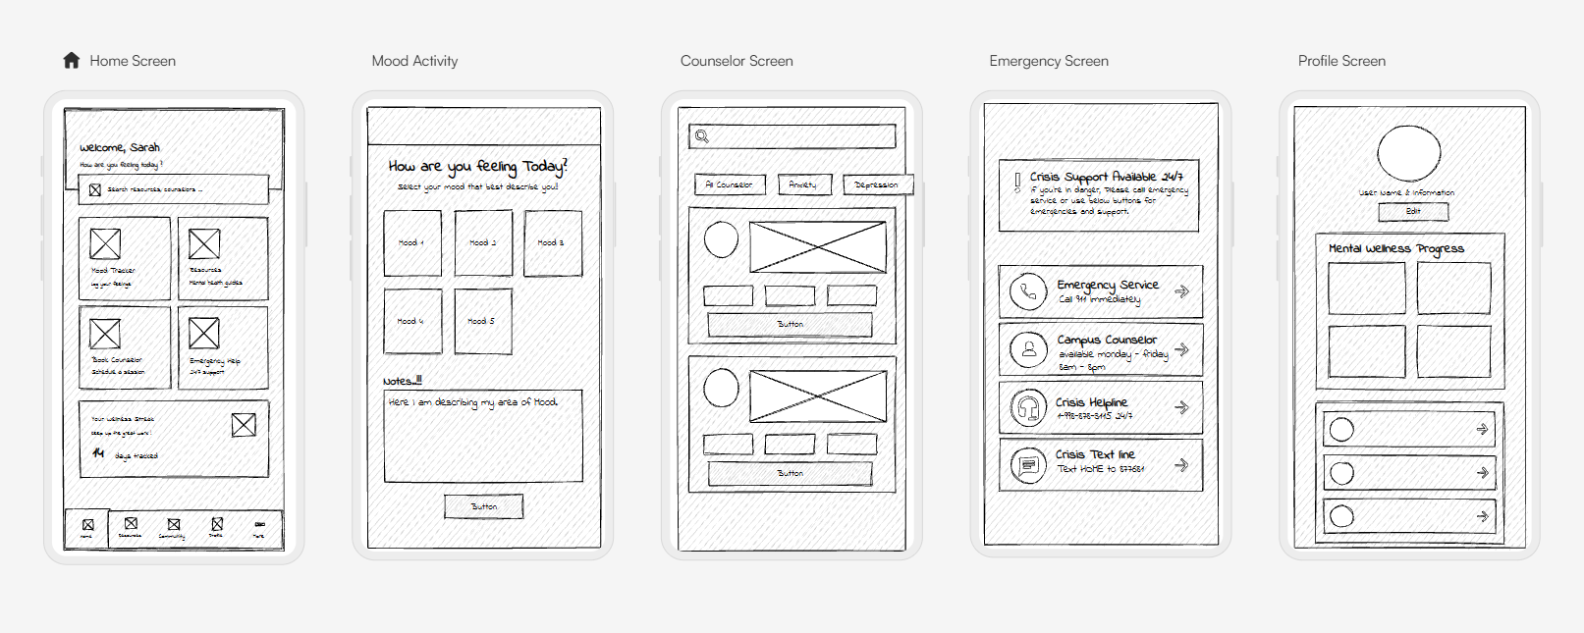
- Document the design thinking process from research to prototype.
5. Design Thinking Process
- Empathize
Conduct research to understand students' mental health concerns and challenges.
Define: Students need a safe, accessible, and confidential platform for psychological support.
- Ideate
Brainstorm features such as:
- Mood tracking
- Mental health resources
- Online counseling
- Emergency support
- Anonymous community support
- Prototype

- Create low-fidelity wireframes in Figma.
- Test
- Gather feedback from students and improve usability.

Thank you From Mahima Singh
An Intern UI UX Designer

